Aufbau des Szenengraphen

Screenshot aQtree | Ogre Scenegraph
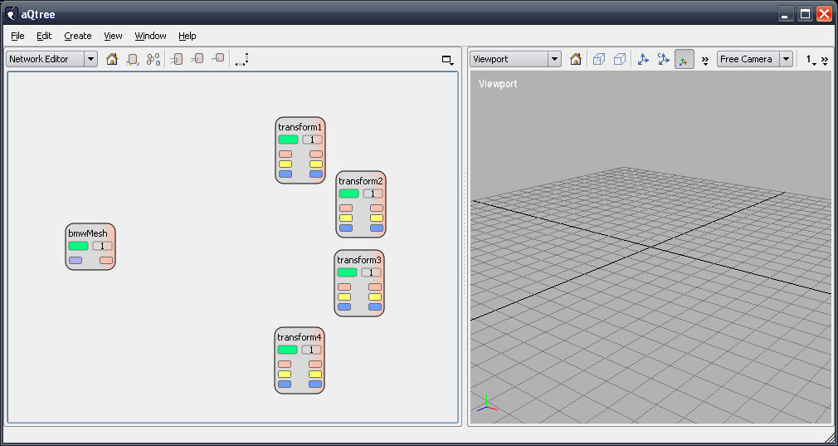 | Root  viewport1  …  stage1  bmwMesh  Entity  transform1  transform2  transform3  transform4
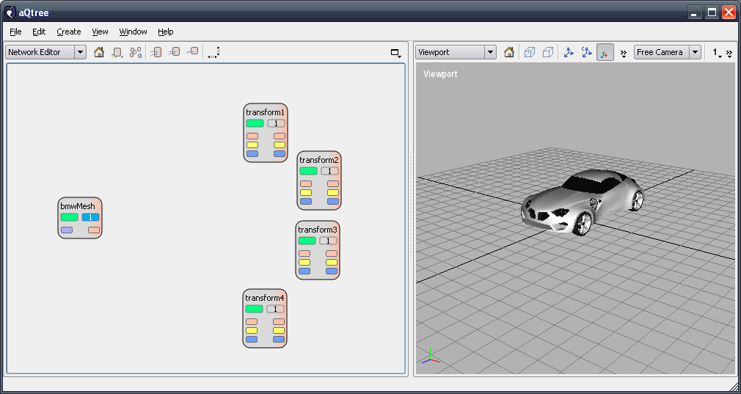 | Root  viewport1  …  stage1  stage1_bmwMesh  stage1_Entity  …
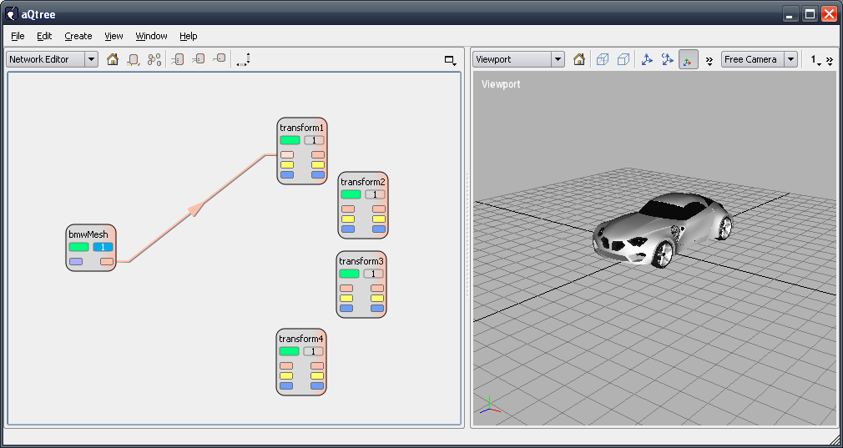 | Keine Änderung
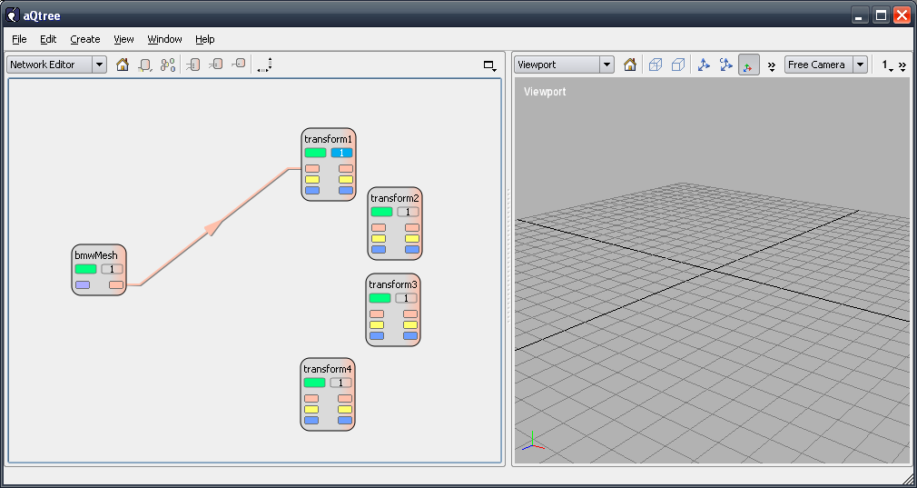 | Root  viewport1  …  stage1  stage1_transform1  stage1_bmwMesh  stage1_Entity  …
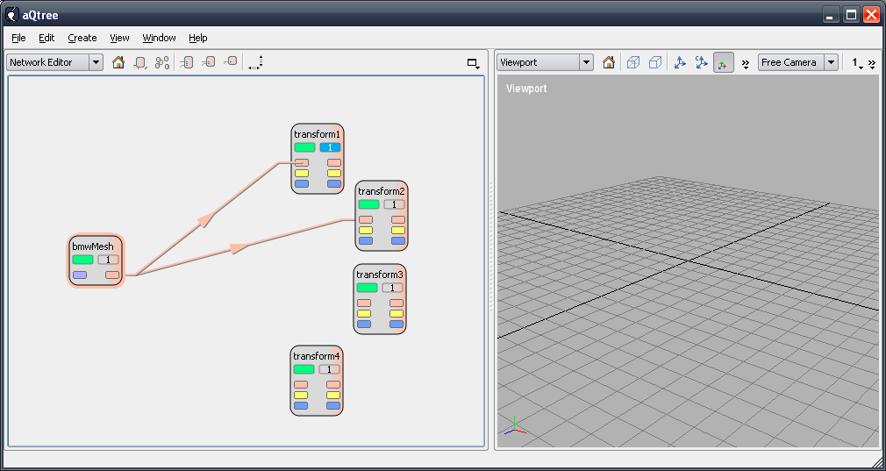 | Keine Änderung
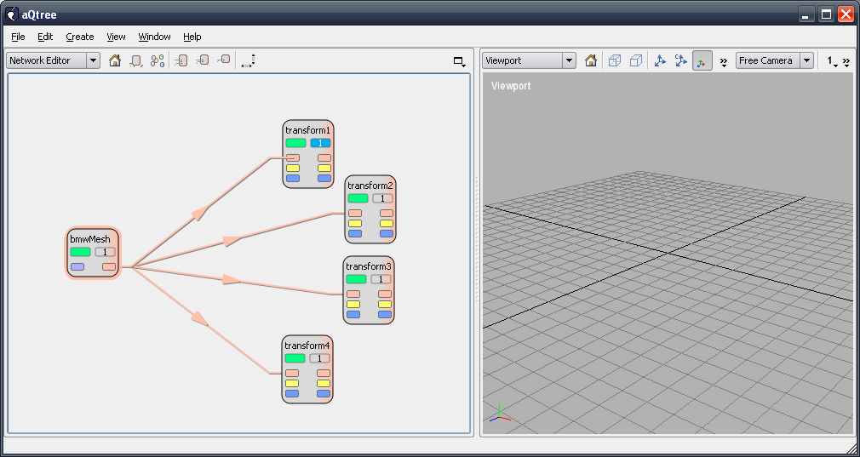 | Keine Änderung
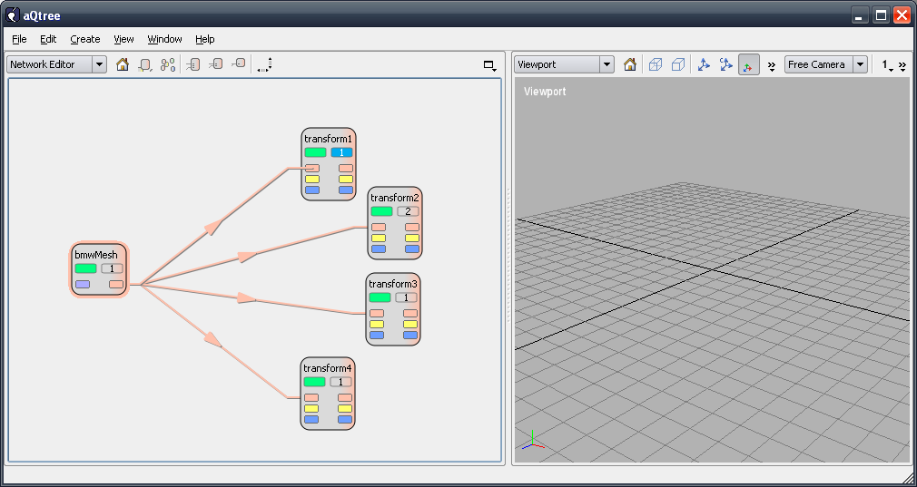 | Keine Änderung
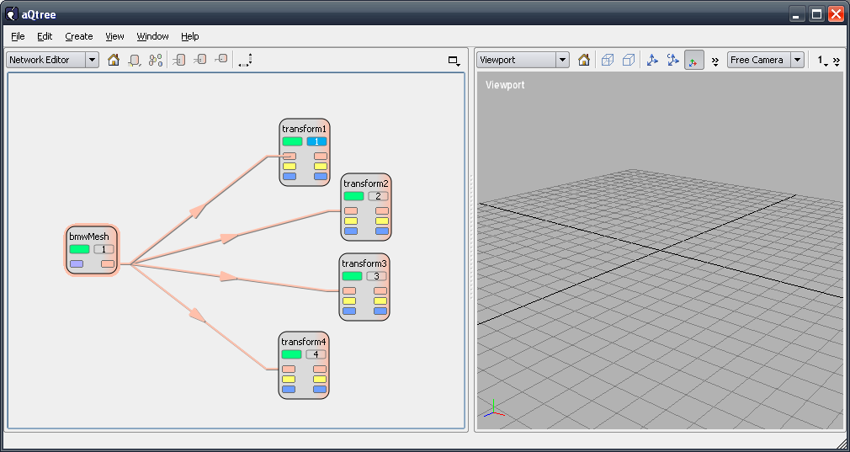 | Keine Änderung
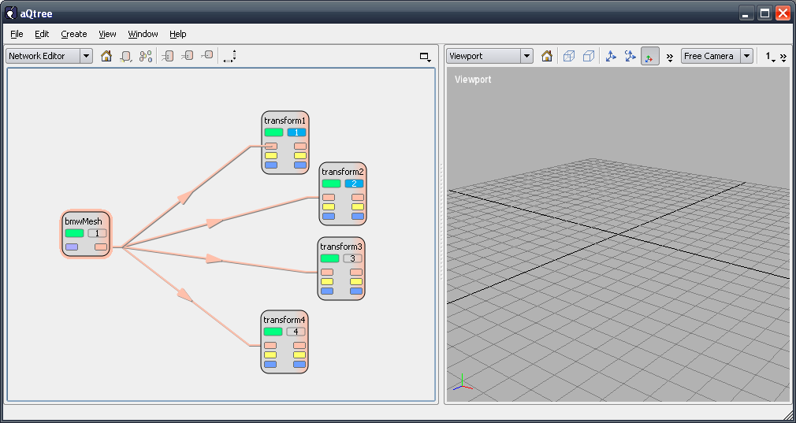 | Root  viewport1  …  stage1  stage1_transform1  stage1_bmwMesh  stage1_Entity  stage2  stage2_transform2  stage2_bmwMesh  stage2_Entity  …
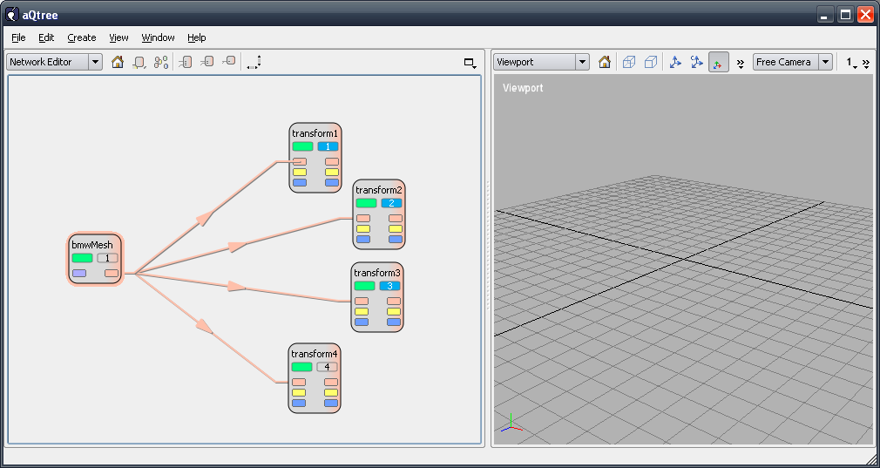 | Root  viewport1  …  stage1  stage1_transform1  stage1_bmwMesh  stage1_Entity  stage2  stage2_transform2  stage2_bmwMesh  stage2_Entity  stage3  stage3_transform2  stage3_bmwMesh  stage3_Entity  …
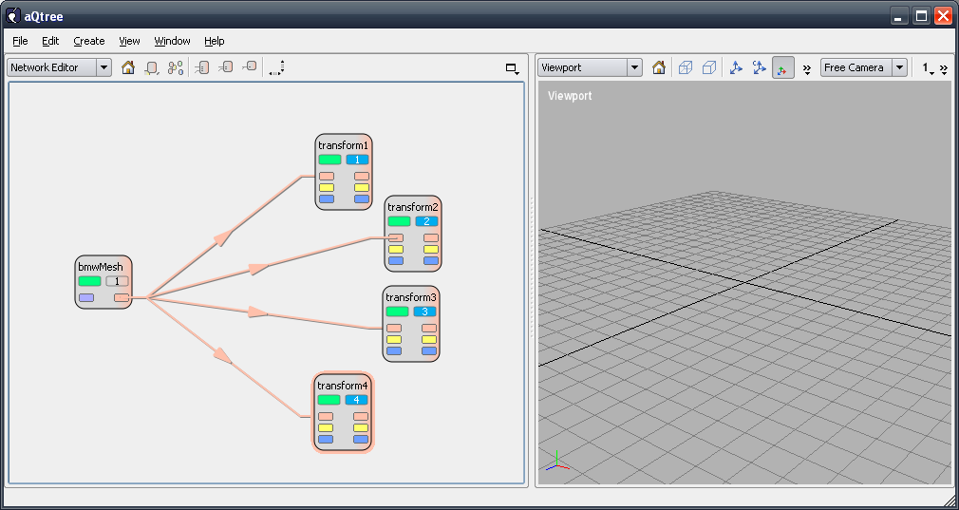 | Root  viewport1  …  stage1  stage1_transform1  stage1_bmwMesh  stage1_Entity  stage2  stage2_transform2  stage2_bmwMesh  stage2_Entity  stage3  stage3_transform2  stage3_bmwMesh  stage3_Entity  stage4  stage4_transform2  stage4_bmwMesh  stage4_Entity  …

